Import DaRWIN

# How it works

The principle is to convert data into a pre-established structured data format (i.e. a “template”), allowing mapping between original data and DaRWIN database fields.

The import is done in three steps:

1. Import of taxonomy : import missing taxons in DaRWIN . This step is optional but recommended . Taxa can also be created during specimen import (step 3), but if too many taxa are new, this can be time)consuming ;
2. Import of localities : import missing sampling localities in DaRWIN. These stations needs to have an unique code (called station id) ;
3. Import of specimens.

DaRWIN import tool reads "tab-delimited" files, that can be created from Excel/Calc.

To allow the link between the 3 templates, the system uses the scientific name (taxon) of the specimen and the code of the station (that is supposed to be unique, while this not always the case in old data). When a specimen is imported, it will be subsequently linked to its taxon and sampling locality pre-existing or previously imported.

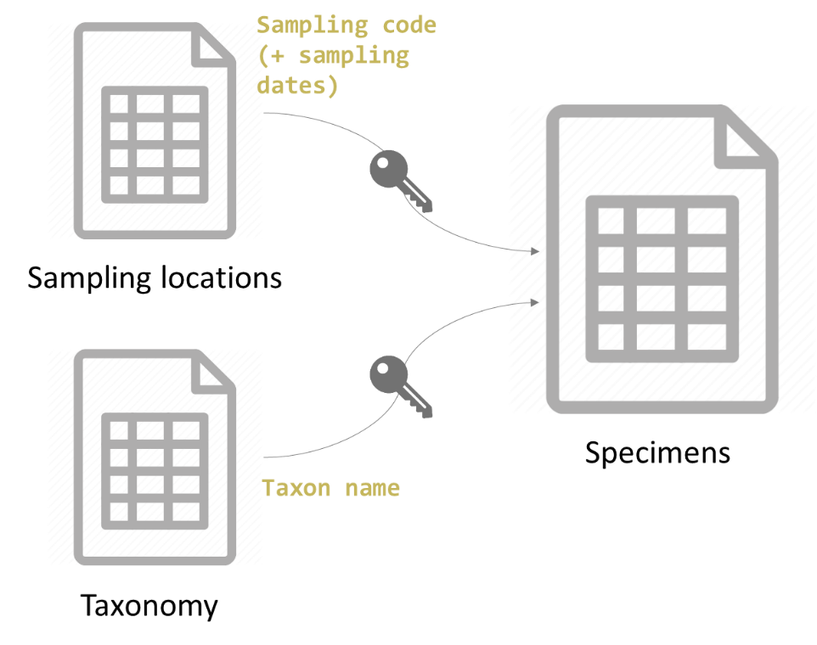

# Taxonomy Import

## Preliminary information

**WARNING ! Intra-data problems: about** half of correction made and identified quality issue after import originates from errors or incomplete data **in original file**. Import has to be prepared with care. Errors in the file will be imported with the data…

→ Examples and consequences:

* Different hierarchy within a file *=> duplicated taxon with different hierarchy* (can be relevant if really different, but not if only some levels are missing like sub- and supra- levels)
* Misspelling *=> duplicated taxon and difficulty to search and find the actual resource*
* Taxon in the wrong level (wrong column) *=> bad hierarchy*
* Vernacular names used in higher levels taxonomy *=> bad taxon and bad hierarchy*

**This kind of errors has consequences for import: if a taxon is not unique, it will not be automatically recognized.** During an import, when a specimen is linked to a taxon for which duplicates (or homonym) exist in Darwin, taxonomy cannot be automatically attributed. Human action is therefore needed to select and confirm which value is correct.

**What if duplicates can have a scientific basis?**

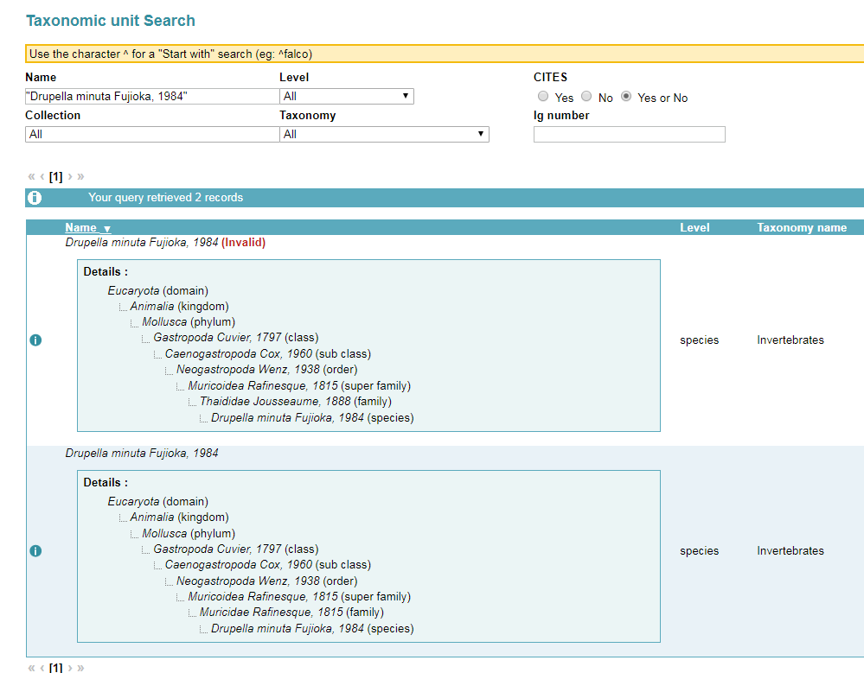

**Fig 1. : example of duplicate taxa in Darwin (families differ)**

They need to be considered in the database.

**Solution**: parallel taxonomies

Two types:

* **Reference taxonomy: one taxon is only present once**

=combination name + author + level is unique in all reference taxonomic level

* **Non-reference:** if you need a parallel taxonomical hierarchy (historical data to store with historical taxon name, temporary taxonomy, user-based taxonomy, etc); can store duplicates **(in Fig1,** “Invertbrates” is therefore a “non-referenced taxonomy, i.e a taxonomy that allows duplicates)

**=> Possibility to group taxa in a specific named hierarchy**

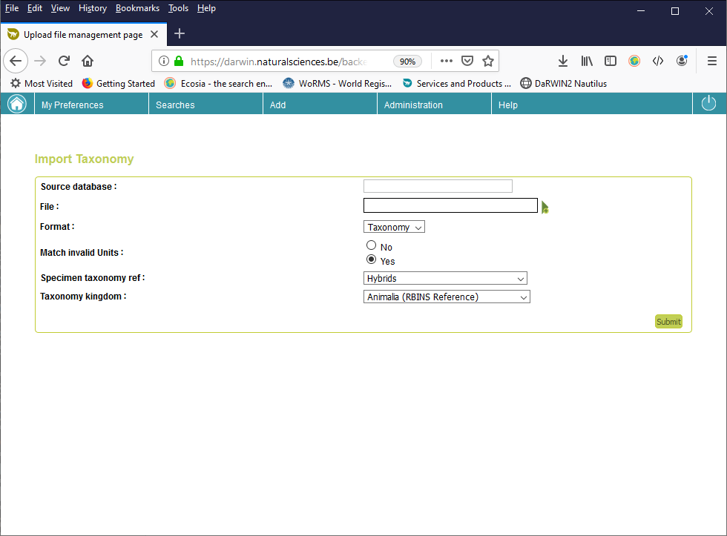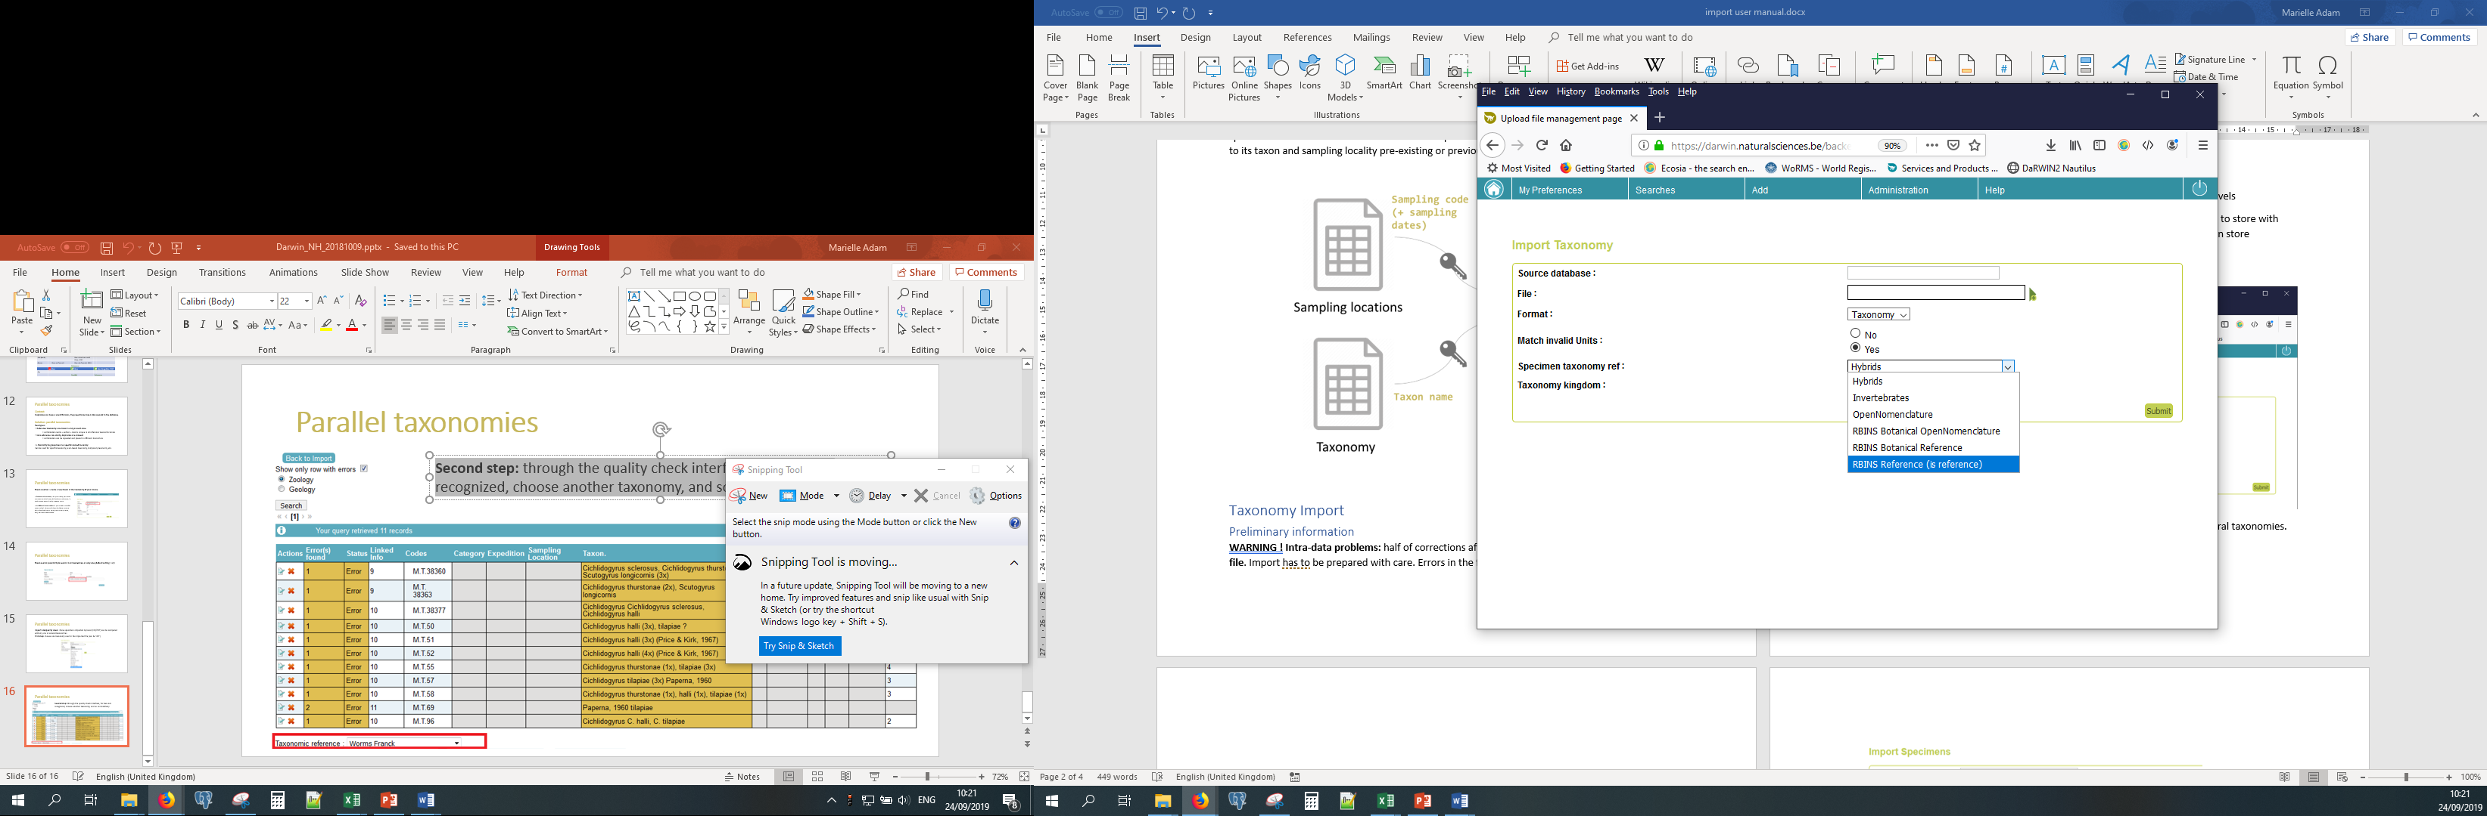

**Fig 2. : how to link the taxa to a taxonomy**

New specimens imported by Excel (in tab-delimited format) can be compared with all, one or several taxonomies (in successive quality-checks).

## Step 1: Prepare your file

You should prepare a file with the list of taxa that are missing in DaRWIN and should be imported. To do so, you first need to know what already exist in DaRWIN and then, what is missing and need to be imported. The missing taxa need to be stored in a tab-delimited file, for import.

### Check taxonomy

A tool for checking taxonomy is available here: <http://nautilus.rbins.be/natural_heritage_webservice/taxonomy/>

Technical information on how to format file are available here:

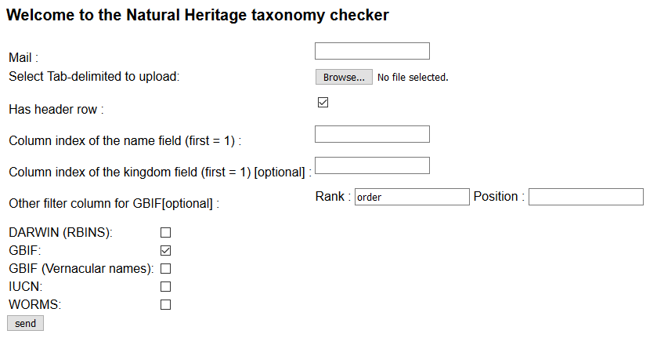

**Fig 3. : the taxon-checker interface**

Mail field to allow mail alert is not yet available.

You can upload a tab-delimited file with taxon names from the file you wish to import, following the structure below:

|  |  |  |  |  |
| --- | --- | --- | --- | --- |
| **scientificName** | **kingdom** | **phylum** | **order** | **family** |
| Mandatory | Optional | Optional | Optional | Optional |
| Name you wish to check | Used to focus on a group of taxon (allows to avoid homonyms in groups that don’t interest you | | | |

You can check on which catalogue you wish to validate your taxonomy.

This tool will help you to know what is in DaRWIN and with which taxonomical hierarchy, and to complete missing taxonomical trees with the system of your choice (GBIF, IUCN, WoRMS, Fishbase).

It is also possible to use the tool available on GBIF website (<https://www.gbif.org/tools/species-lookup>) or on WoRMS website (<http://www.marinespecies.org/aphia.php?p=match>).

### Import missing taxonomy

The file has to be saved in tab-delimited format (*.txt).

The list of fields (or column names) for taxonomy import file is available in Annex 1.

Please, use exactly the same spelling for column name.

The final file to import should contain all missing taxa that you wish to load in DaRWIN. Each line therefore contains all missing levels and the lower known parent in DaRWIN. Example: you wish to import a new species name. If the genus already exists in DaRWIN, you only need to mention this genus in your file. If you want, you can add all higher levels, but it is not recommended (this would actually increase the risk of creating a duplicate in case of misspelling).

A name that is already present in DaRWIN, and also present in import file with the same form and hierarchy will be recognized by the system during import and will not be imported. On the contrary, a new name will be imported if a parent is in the file (i.e a family foe genus). If you aim to match an existing taxonomical tree in DaRWIN, to connect a new sub-tree by import, you have to refer to the exact same names to ensure the matching between DaRWIN and import.

*Example 1 : “Alligatoridae Cuvier” exists in DaRWIN –in a reference Taxonomy. If you use “Alligatoridae” (without the author) in your file, it will not be recognized, and nothing will be imported.*

*Example 2 : if you use “Alligatoridae Cuvier” as family and “Melanosuchus” as genus in your file for import in reference taxonomy, “Melanosuchus” will be created and it ends in appearance of a duplicate taxon, i.e. “Melanosuchus” and “Melanosuchus Gray, 1862”.*

If you need parallel taxonomies, you must prepare one file by taxonomy (example: one for Reference taxonomy, and a second for a temporary taxonomy).

## Step 2: Import in DaRWIN

Import itself is a quite rapid process. Enter the import tool, through menu Administration > Imports > Taxonomy

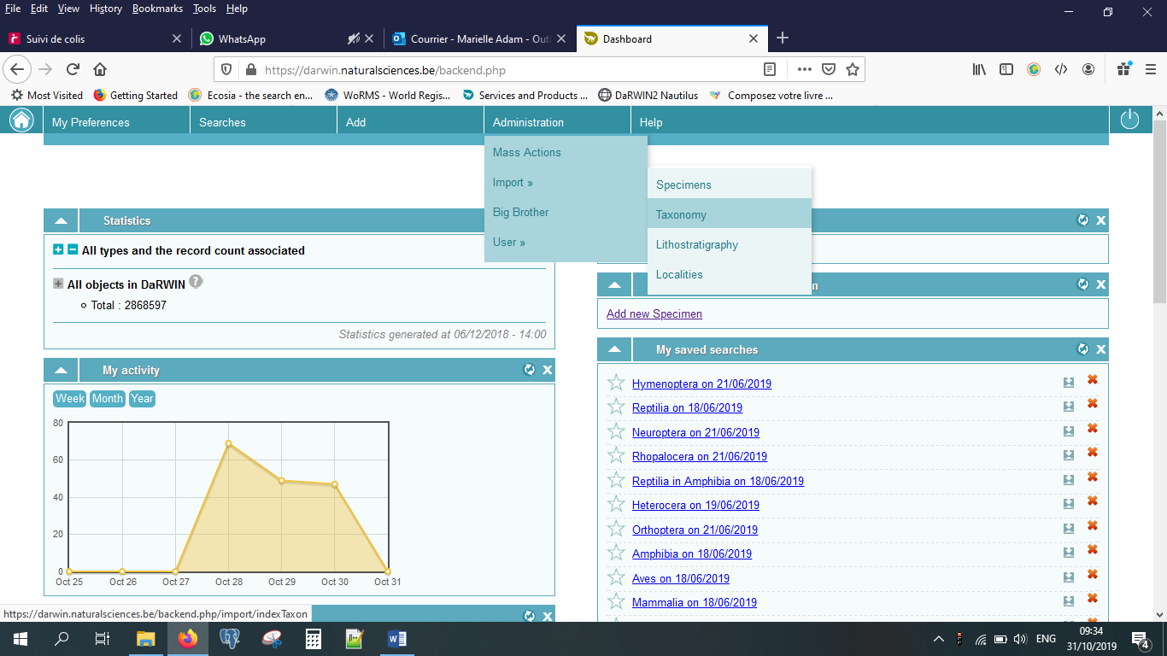

**Fig 4.a : menu to import new taxa**

A summary table listing all previous imports appears. From this page, you can :

1. filter taxonomy imports by filename, state of import or show only finished files
2. sort results by id and date
3. ask to import a new file

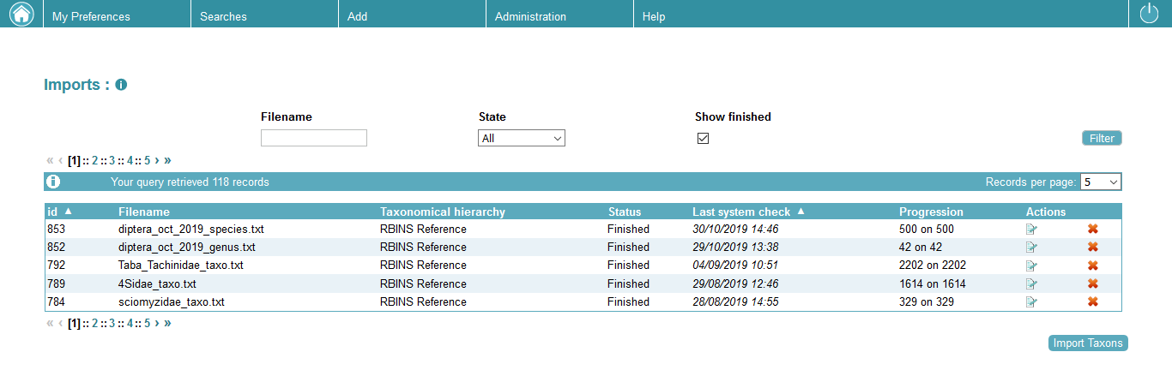

**2**

**3**

**1**

**Fig 4.b :list of import files and processes**

At the bottom of this table, click on “Import taxons”. You will be redirected to the import file form.

In this form, you mention:

* the source database, as a reminder. Ex: “Collection Congo 1956”
* click on the “File” field, a file explorer opens, and you can select the *.txt file containing the taxonomy you wish to import
* select in which taxonomy you wish to import, mainly “RBINS Reference (is reference)”
* precise kingdom, basically “Animalia (RBINS Reference)”

Then, you click on submit.

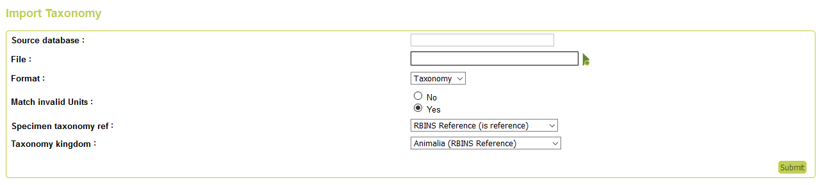

**Fig 4.c interface to import taxonomy file with its metadata**

The system uploads your file in memory and waits for you to ask him to load the data in its intermediate table, called “staging”/ This intermediate table allows to launch, interruptand resule semi-automated tests fo quality-check.

Click on “Load in staging” at the end of the line that concerns your current import.

When file is loaded in staging, system waits for you to ask him to check (ie. compare and marge with existing data in Darwin) information and import what it can import (new data). You could need to refresh the page to see this updated state appear.

At the end of the check process, import is finished. And you can see the result by clicking on icon at the end of the line.

Here are the errors that can appear:

|  |  |
| --- | --- |
| **imported_taxon** | **The taxon has been imported** |
| **taxonomic_hierarchy_already_exists** | *The taxon already exists with the same hierarchy* |
| **taxonomic_conflict** | *The taxon already exists in the taxonomy, with another hierarchy* |
| **taxon_to_be_created_without_suitable_parent** | *The taxon is new, but is dependant of a parent that already exists in the same taxonomy with another hierarchy* |
| **taxon_to_be_created** | *The taxon exists on same taxonomy with different author.*  *It is also an error that can appear for other technical reasons. If you are not sure, you can contact administrator.*  *You can try to import your specimens anyway.* |

Keep in mind that existing hierarchies’ warnings are normal for parent taxa that you use to connect your new taxonomical tree (i.E : you have to mention the full hierarchy lf the family when you import a new genus).

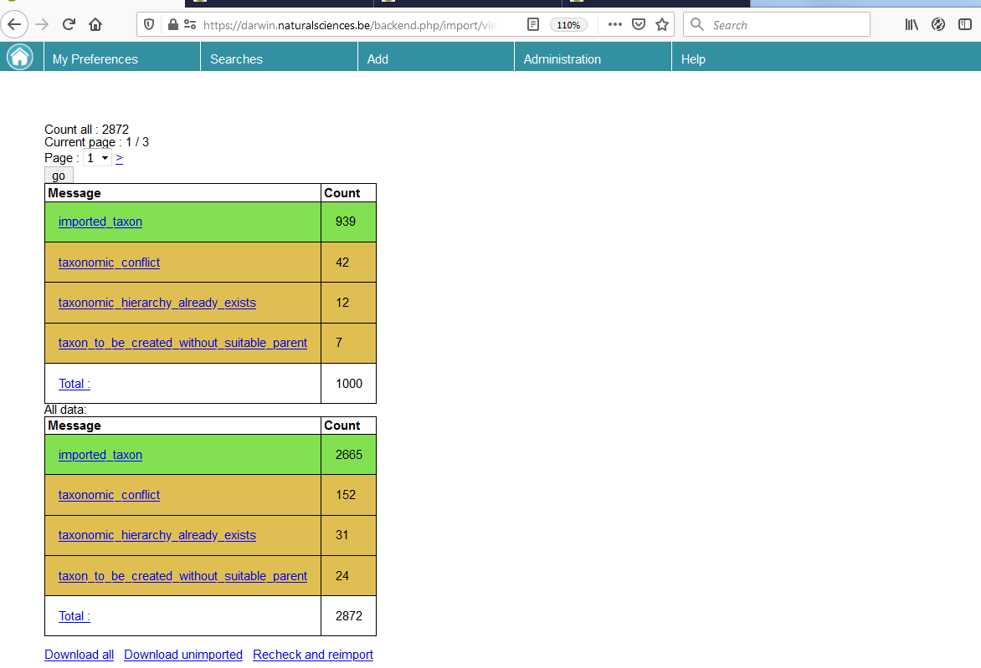

**Fig 5. navigational menu summarizing the taxonomic errors occurred at importation**

# Specimens Import

## Step 1: Prepare your file

The data have to be stored in a spreadsheet (Excel/LibreOffice) and then be converted into a tab-delimited file (with the *.txt extension).

The fields available in the template are listed in **Annex 2.**

Unrecognized columns will be imported as a property. You can therefore use any other column name to create.

Please, use the exact same spelling, as misspelling in column names may displace a field value into property!

## Step 2: Load your file

Import itself is a rapid process. Enter the import tool, through menu Administration > Imports > Specimens

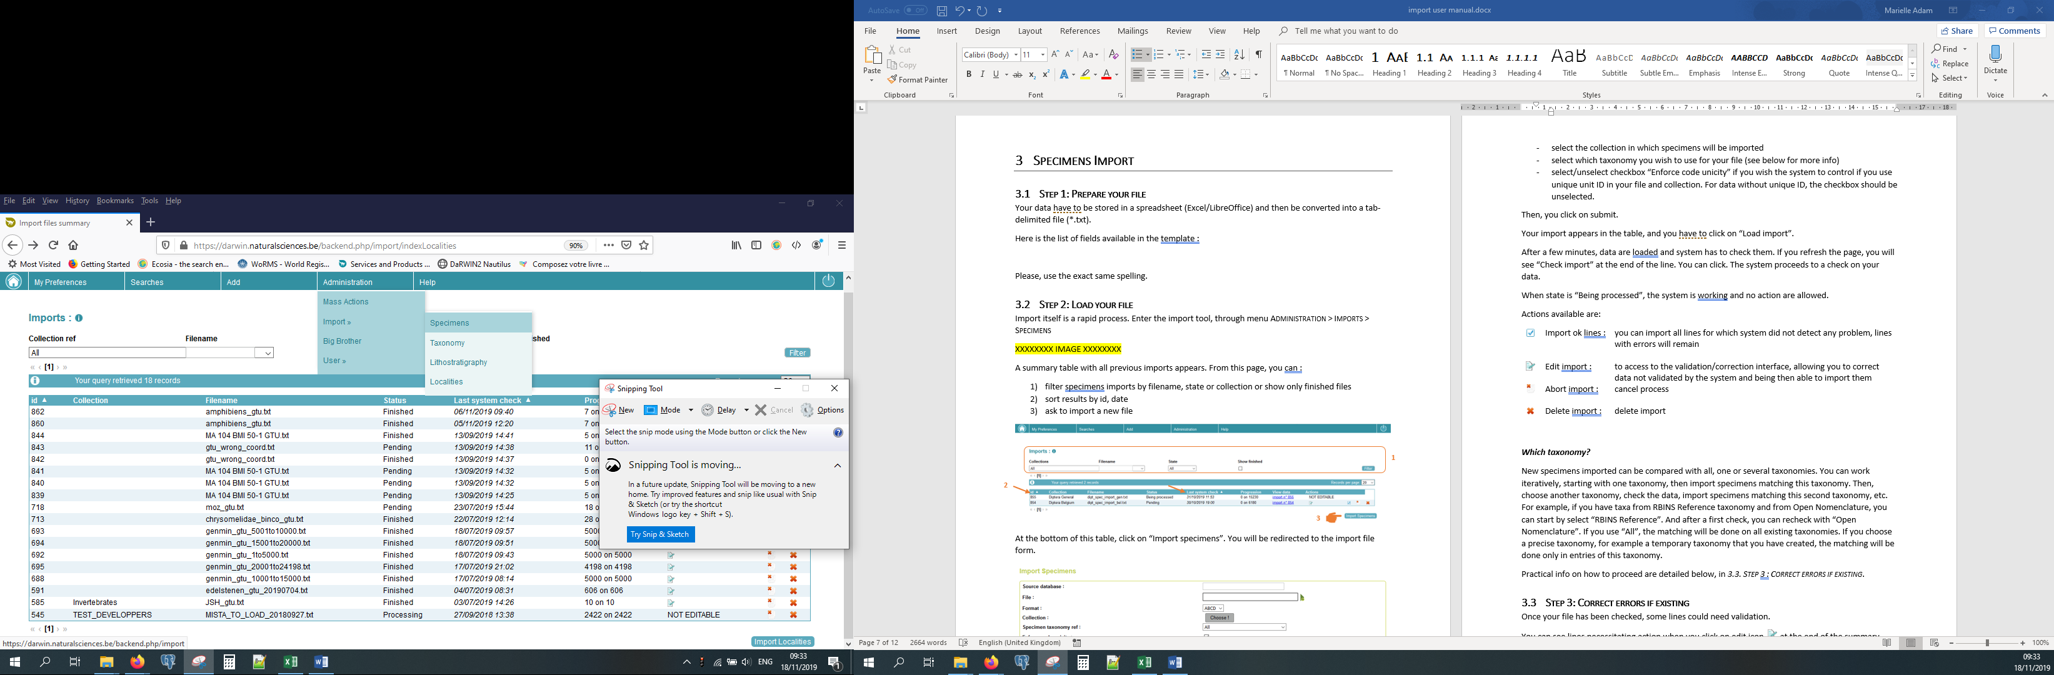

**Fig 1. Navigational menu to the specimen import page**

A summary table with all previous imports appears. From this page, you can:

1. filter specimens imports files by filename, state or collection or show only finished files
2. sort results by id, date
3. ask to import a new file

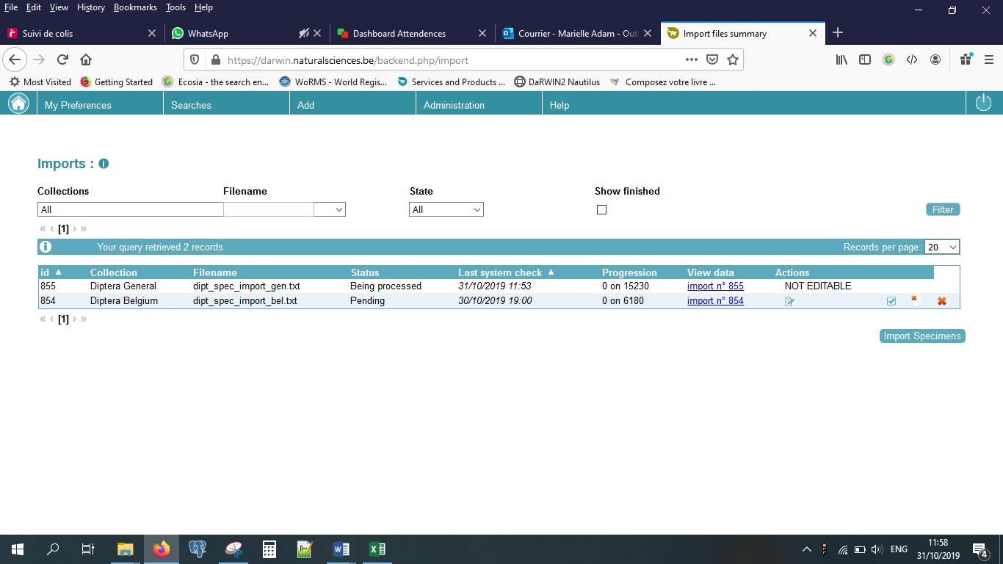

**2**

**3**

**1**

**Fig 2. Import files overview**

At the bottom of this table, click on “Import specimens”. You will be redirected to the import file form.

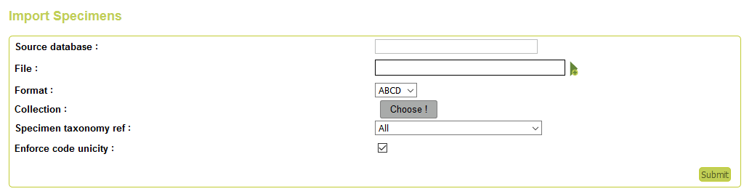

**Fig 3. Interface to import specimen files, with its metadata**

In this form, you mention:

1. the source database, as a reminder. Ex: “Collection Congo 1956”
2. click on the “File” field, a file explorer opens, where you can select the *.txt file containing the specimens you wish to import
3. select the target-collection in which specimens will be imported
4. select which taxonomy you wish to use for your file (see below for more info)
5. select/unselect checkbox “Enforce code unicity” if you wish the system to control the uniqueness Unit ID (ie sample number) in your file and collection. For data without unique ID, the checkbox should be unselected, otherwise import will be stopped. It is also possible to create an sequential unique ID and give it to specimen that do not have one (see below)
6. then, you click on submit.

Your import appears in the list, and you have to click on “Load import”.

After a few minutes, data are loaded, and the system has to check them. If you refresh the page, you will see “Check import” at the end of the line. You can click. The system proceeds to a check on your data.

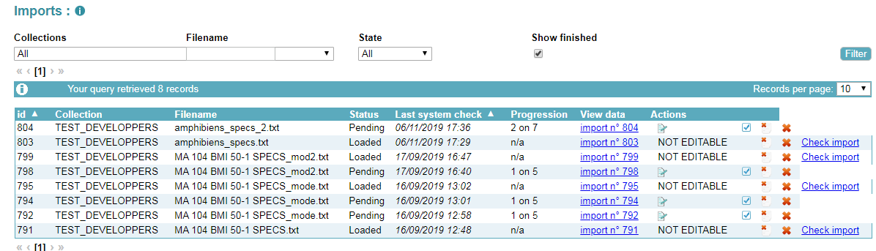

**Fig 4. The “check import” button**

When state is “Being processed”, the system is working, and no action are allowed.

Actions available are:

|  |  |  |
| --- | --- | --- |
|  | Import ok lines : | you can import all lines for which system did not detect any problem, lines with errors will remain |
|  | Edit import : | to access to the validation/correction interface, allowing you to correct data not validated by the system and being then able to import them |
|  | Abort import : | cancel process |
|  | Delete import : | delete import |

***Which taxonomy?***

New specimens imported can be compared with all, one or several taxonomies. The last possibility is iterativel starting with one taxonomy, then import specimens matching this taxonomy. Then, choose another taxonomy, check the remaining data, import specimens matching this second taxonomy, etc…

For example, if you have taxa from RBINS Reference taxonomy and from Open Nomenclature, you can start by select “RBINS Reference”. And after a first check, you can recheck with “Open Nomenclature”. If you use “All”, the matching will be done on all existing taxonomies. If you choose a specific taxonomy, for example a temporary taxonomy that you have created, the matching will be done only in entries of this taxonomy.

Practical info on how to proceed are detailed below, in *3.3. Step 3 : Correct errors if existing*.

## Step 3: Correct errors if existing

Once your file has been checked, some lines could need validation.

You can see lines needing action when you click on edit icon  at the end of the summary imports table.

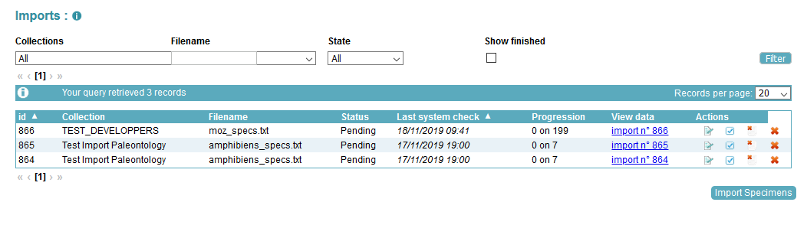

**Fig 5. The “edit import” button**

You are redirected to a validation screen, listing all lines in error.

***What does it mean?***

Some information stored in your file are linked to tables in DaRWIN database. It means that the system has to compare your value and see if it can be matched with an existing value in DaRWIN.

Your value can match several entries, like a person name. Take Wilson as an example. Several occurrences appear for this name. But the system cannot guess which is the one your target. Wilson M.? Wilson Brad? You have to specify.

Your value could also not be recognized. This is a common situation in taxonomy. You have to give precision.

This mechanism of comparison between Darwin and the importation file concerns the following concepts :

1. taxon name
2. chronostratigraphic classification
3. lithostratigraphic classification
4. mineralogical name
5. lithological name
6. institution name
7. the I.G. (“Inventaire Général”) number
8. expedition name
9. identifier
10. collector
11. donator
12. institution
13. the specimen code « UnitID » and main code number (**if the collection doesn’t allow duplicates**)
14. the station id (gtu id))

***What can be done?***

In both case, you have to click on edit icon  at the beginning of each line. You are then redirected to a form, that allows you, for each value in error, to search for the value in DaRWIN through the magnifier icon  next to the field.

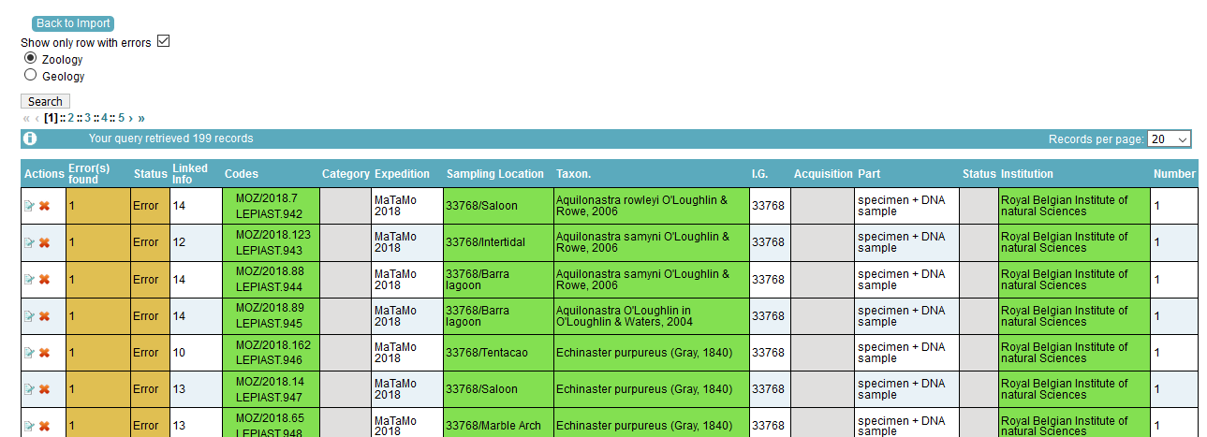

**Fig 6. The “edit import” button (to specific field)**

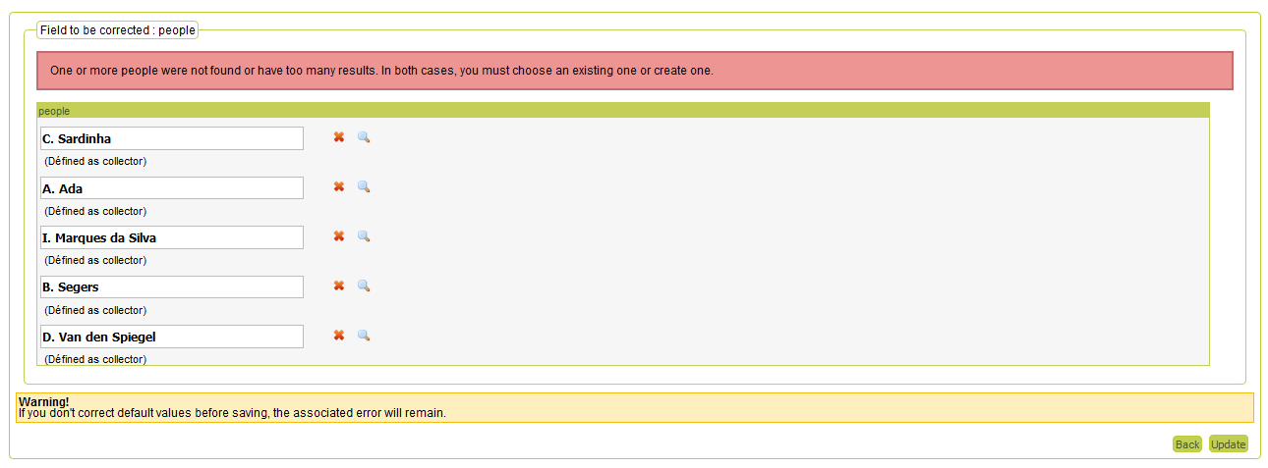

**Fig 7. Example of error message (duplicates in names of collectors)**

**and of correction screen**

It will then open a pop-up window, that is the same as the one you are used to in DaRWIN (creation of records, selecting linked info like taxon when adding a new specimen, etc.). You search for your value, and click on “Choose” to confirm an unambiguous value, or you can create it, and then choose it.

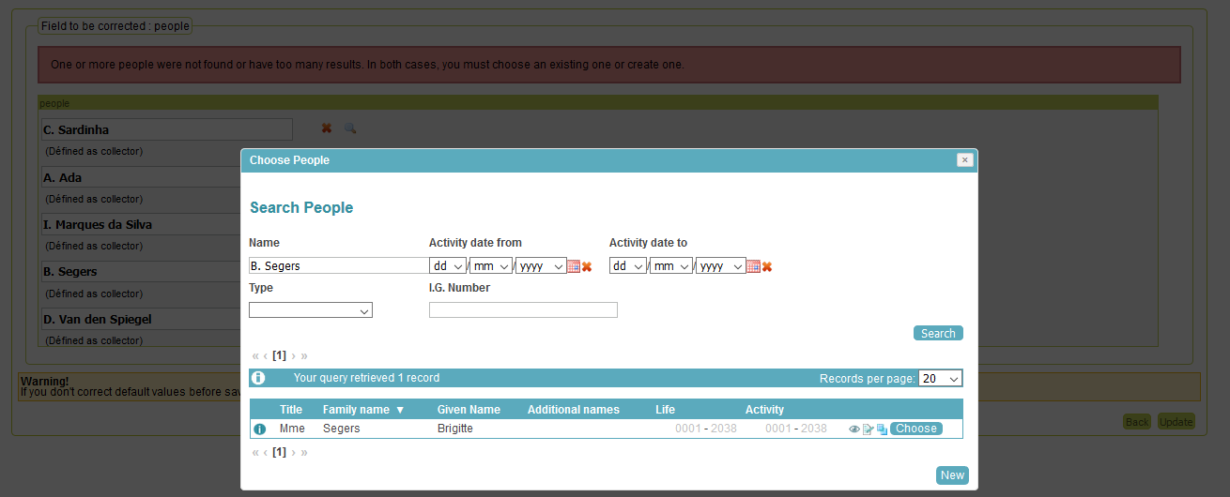

**Fig 8: disambiguating a collector (initials replaced by complete surname)**

When you are done with corrections, you can click on “Update”. You can also leave the correction for later and click on “Back” that send you back to the list of errors.

When you click on “Update”, the system will update information from data you have imported in temporary file, to make them match existing data in DaRWIN. If the same error (same data for same fields) is present more than once, one correction is enough and applied recursively The system will update all lines having similar value.

***And what about taxonomy?***

As previously mentioned, it is possible to use several taxonomies during one import.

At the beginning of the import process, when you load the file, you choose one taxonomy.

If some taxonomic names are left unrecognized after the first check, you can choose another taxonomy, and click on “check”. The system will perform a re-recheck comparing data to see if unrecognized taxa can be linked to this other taxonomy. By doing so, you will be redirected to the summary table page, letting the system work on the recheck. When it is done, icons for edition, import, abort import or delete import will be available again.

And so on, for each taxonomy you wish to use, iteratively.

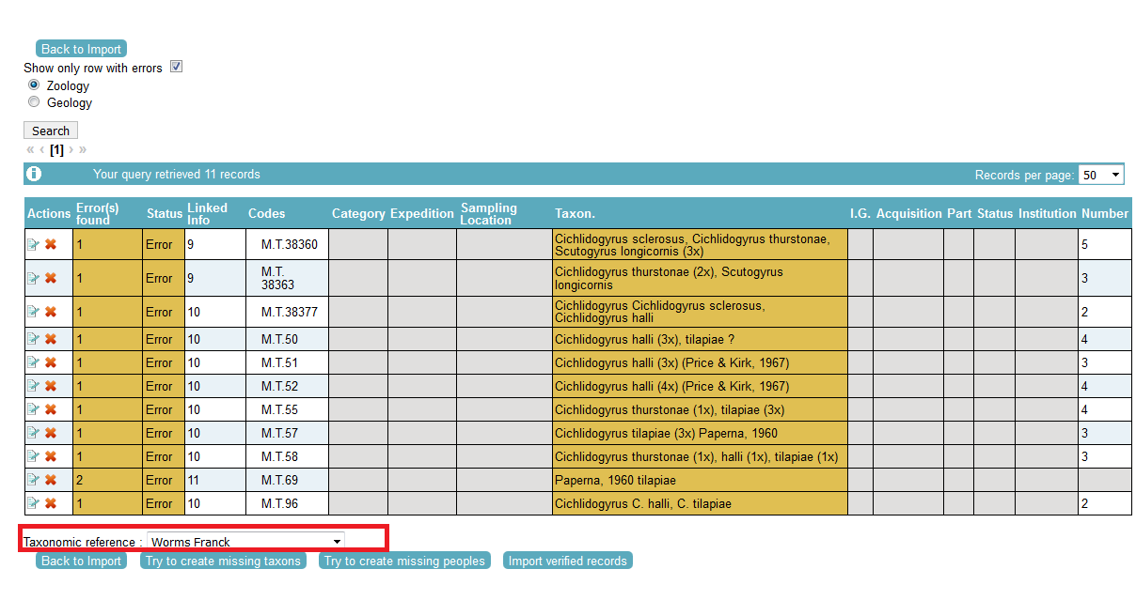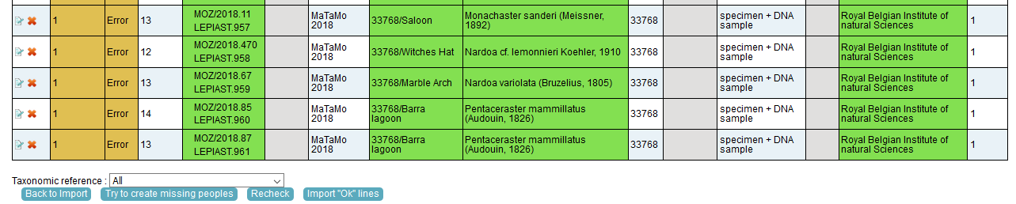

**Fig 9: Change reference taxonomy used at importation**

There can also appear errors if you use the wrong format, for example for numeric fields like totalNumber. Import file *.txt must be corrected and reimported in that case.

It is also possible (but not recommended) to create people’s name left unrecognized before re-checking the data. In this case the name and surname will be merged in the same field, and groups of collectors will be imported as one value.

## Step 4: Import OK lines

You can import “OK” lines when you are done with corrections. It is also possible to import all ok lines, when some lines are still to be corrected.

It could happen if you have corrected a part of lines, and wish to already send them in DaRWIN, leaving remaining corrections for later.

Or it can also be necessary if you wish to check data on 2 different taxonomies. You will then correct all lines that concern taxonomy you selected in the beginning of the import process. Then import them. And after, re-check data against another taxonomy.

## Create specimen numbers

The “UnitID” field is not mandatory if the collection is configured with the “auto-incremented” flag on. Darwin can be used to create and assign these numbers to the specimen during the file importation of the file. Please check these collection settings with the curator(s) of the physical collection, as this has an impact on label printing, loans and other domain.

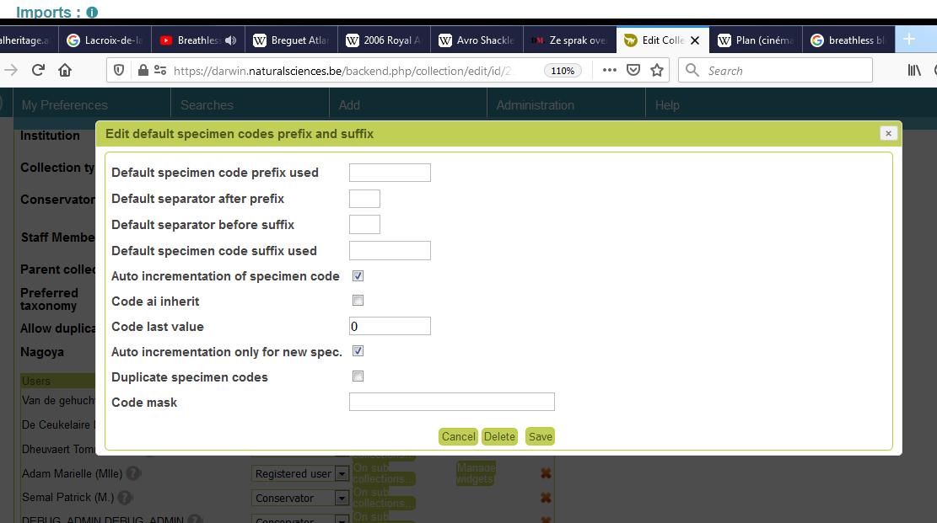

**Fig 10: Auto-increment settings at collection level**

Auto-increment settings are :

1. **Auto increment of specimen code :** enables auto-increment for the collection
2. **Code AI inherits :** if enabled, sub-collections and parent collections share the same values and sequences (useful if the sub-collection is for collectors)
3. **Code last value** : can re-set the base value to calculate the auto-increment (should be updated automatically). Usefull for filling (or creating) “gaps” if needed
4. **Auto incrementation only for new spec:**  Not used
5. **Duplicate specimens codes :** if enabled, the insertion interface enforces by default a unicity check on the main code (that can be overpassed)

Note that by default, the import file page always enable this setting by default . This setting can also be disabled when uploading the file . This setting at collection level only specifies that the check is enabled by default, but is not related to a database constraint.

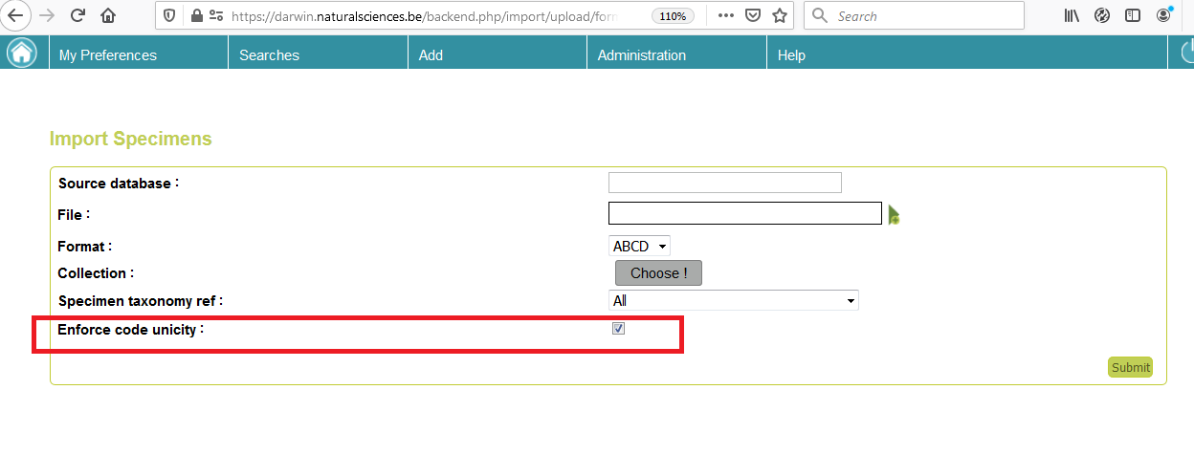

**Fig 11: Enable/disable code unicity check in file import**

**!!! WARNING: Don’t “import ok lines” for more than one file at the same time. Once you click on “import ok lines” for an import, you have to wait for this file to be proceeded and imported before importing other lines. The system is slow when the same user import two files at the same time**

# Localities Import

## Step 1: Prepare your file

Imported data have to be stored in a spreadsheet (Excel/LibreOffice), and then converted into a tab-delimited file (*.txt).

The fields available in the template are listed in Annex 3.

Please, use the exact same spelling.

## Step 2: Load your file

Import itself is a rapid process. Enter the import tool, through menu Administration > Imports > Localities

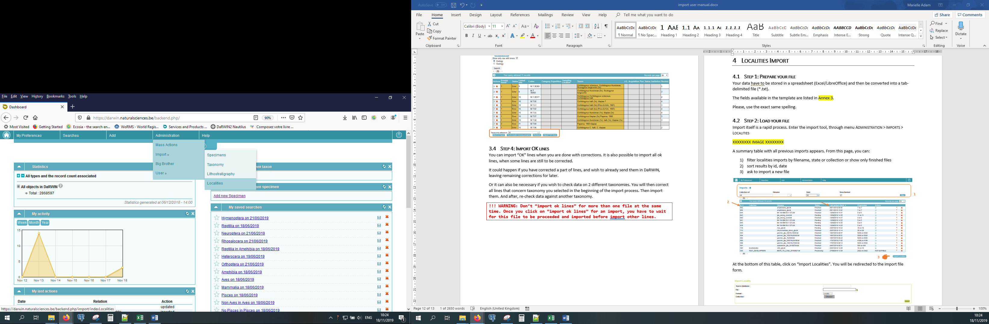

**Fig 1: Navigational menu to import localities (**

These values end up in the Gtu table and its related comments, properties and tags .

A summary table with past imports appears. From this page, you can:

1. filter localities imports by filename, state or collection or show only finished files
2. sort results by id, date
3. ask to import a new file

 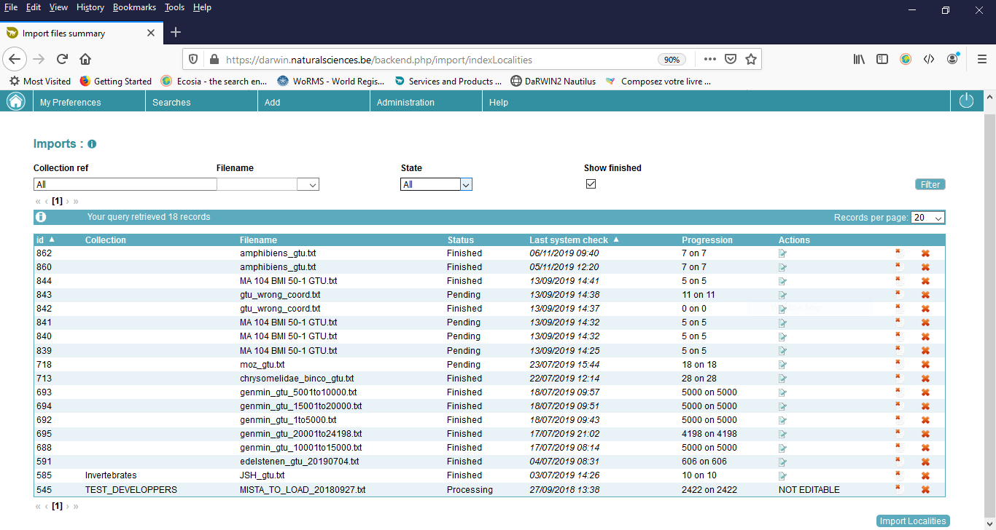

**3**

**2**

**1**

**Fig 2: List of template import for localities**

At the bottom of this table, click on “Import Localities”. You will be redirected to the import file form.

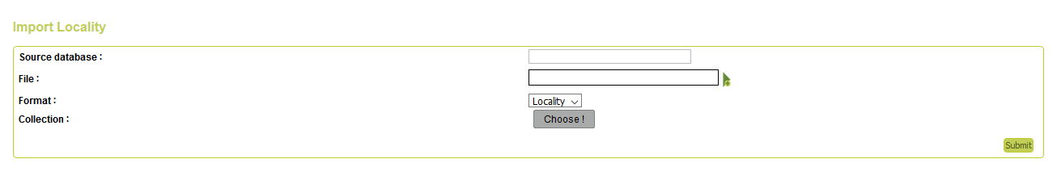

**Fig 3: Locality import interface**

In this form, you mention:

1. the source database, as a reminder. Ex: “Collection Congo 1956”
2. click on the “File” field, a file explorer opens, and you can select the *.txt file containing the specimens you wish to import
3. (optional) select the collection in which specimens have to be imported; in this case, you can only access it through this collection. Not advised for a classical use of import tool.

Then, you click on submit.

Your import appears in the table, and you have to click on “Load import”.

After a few minutes, data are loaded, and system has to check them. If you refresh the page, you will see “Load GTU in DB” at the end of the line. You can click. The system imports all data without error.

After import, you can access a summary of import by clicking on edit icon . Lines in green were imported. Lines in orange are in error.

List of errors for code:

* **Duplicate code inside file**: line is equivalent to another line in the file.
* **Code already in DaRWIN**: a sampling location with the same code already exists in database. It is the possible to correct your code or to force import.

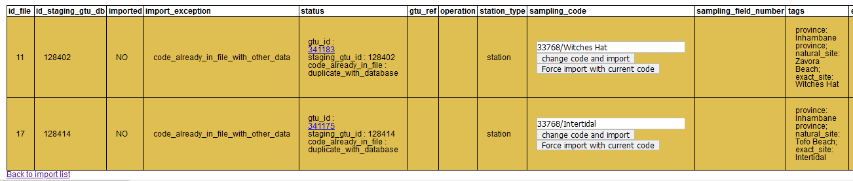

WARNING !! If you change a sampling code because it already exists in database, don’t forget to update your specimens, in order to link the correct locality…

. Note that the import procedure may automatically convert coordinated in the form ‘10° 45’ 56” W’ ‘9° 45’ 56” N’ into their corresponding decimal values (watch out that you didn’t forget the minutes and seconds signs).

There can also appear errors if you use the wrong format, for example for coordinates. You will then see ‘**wrong_dms_coordinate_format**’Import file *.txt must be corrected and reimported in that case.

# ANNEXES

## ANNEX 1 – Template fields taxonomy

|  |
| --- |
| domain |
| kingdom |
| super_phylum |
| phylum |
| sub_phylum |
| super_class |
| class |
| sub_class |
| infra_class |
| super_order |
| order |
| sub_order |
| infra_order |
| section |
| sub_section |
| super_family |
| family |
| sub_family |
| super_family |
| family |
| sub_family |
| super_tribe |
| tribe |
| infra_tribe |
| genus |
| sub_genus |
| species |
| sub_species |
| variety |
| sub_variety |
| form |
| sub_form |
| abberans |
| author_team_and_year |

## ANNEX 2 – Template fields specimens

|  |  |  |  |
| --- | --- | --- | --- |
| **Field** | **Widget** | **Widget field** | **Short description** |
| **Sample identification** | | | |
| **unitID** | Codes | Code (with category "Main" by default) | OPTIONAL (see above)- Unique alphanumeric identifier of specimen |
| additionalID | Codes | Code (with category "Additional" by default) | Additional alphanumeric identifier |
| accessionNumber | I.G. number | - | I.G. number |
| acquiredFrom | Donators or sellers | - | How gived or selled the specimen (if more than one person, separate each name with ";") |
| acquisitionType | Acquisition | Acquisition category | Donation, purchase, mission? |
| acquisitionYear | Acquisition | Acquisition date | Date of acquisition |
| acquisitionMonth | Acquisition | Acquisition date | Date of acquisition |
| acquisitionDay | Acquisition | Acquisition date | Date of acquisition |
| **Sampling location: who, where and when collected?** | | | |
| samplingCode | Sampling location | Sampling location code; link to Sampling location catalogue, should the exact same code as in DaRWIN | Code in Sampling locations catalogue, that identifies collecting or observation station |
| collectionStartDay | Sampling location | Gtu from date | Collecting date |
| collectionStartMonth | Sampling location | Gtu from date | Collecting date |
| collectionStartYear | Sampling location | Gtu from date | Collecting date |
| collectionStartTimeH | Sampling location | Gtu from date | Collecting date |
| collectionStartTimeM | Sampling location | Gtu from date | Collecting date |
| collectionEndDay | Sampling location | Gtu to date | Collecting date (end if needed) |
| collectionEndMonth | Sampling location | Gtu to date | Collecting date (end if needed) |
| collectionEndYear | Sampling location | Gtu to date | Collecting date (end if needed) |
| collectionEndTimeH | Sampling location | Gtu to date | Collecting date (end if needed) |
| collectionEndTimeM | Sampling location | Gtu to date | Collecting date (end if needed) |
| collectedBy | Collectors | - | How collected specimens (if more than one person, separe each name with ";") |
| expedition_project | Expedition | - | Expedition |
| localityText | Comments | Notion "Sampling locations" | Comment on locality, for this particular specimen |
| **Specimen description** | | | |
| kindOfUnit | Part | Specimen part | Part(s) of organism or class of materials represented (animal, mounted specimen, microscopic preparation, part of organism, fossil, etc.) |
| typeStatus | Type | - | Type (paratype, holotype, etc.) |
| lifeStage | Stage | - | Phase or life stage (juvenile, larva, caterpillar) |
| socialStatus | Social status | - | Social status (worker, etc.) |
| sex | Sex | - | M or male = Male, F or female = Female, U or unknown = Unknown, N = Not applicable (for a fungus in a herbarium), X = Mixed (mixed specimens, males and females). |
| totalNumber | Count | Specimen count | Total number |
| maleCount | Properties | Value (Property type: "N males") | Number of males |
| femaleCount | Properties | Value (Property type: "N females") | Number of females |
| sexUnknownCount | Properties | Value (Property type: "N sex unknown") | Number of unknown gender |
| fixation | Properties | Value (Property type: "fixation") | Fixative or anesthetics used prior to tissue preservation |
| samplingMethod | Collecting method |  | Material and/or method used to collect the specimen |

|  |  |  |  |
| --- | --- | --- | --- |
| **Identification information** | | | |
| fullScientificName | Taxonomy | link to Taxonomy Catalogue, should be the exact same name as in DaRWIN | Taxon in Taxonomy catalogue, that identifies specimen taxon |
| identifiedBy | Identifications | Identifier | Identifier name (of more than one person, separate each name with ";") |
| identificationYear | Identifications | Date | Date of identification |
| identificationMonth | Identifications | Date | Date of identification |
| identificationDay | Identifications | Date | Date of identification |
| identificationNotes | Comments | Value (Notion: "Identifications") | Additional information/remark about identification of specimen |
| referenceString | External Links OR Comment | If link, goes to External Links; if character string, goes to comments with notion "Identifications" | References that were used by the identifier to provide the identification |
| **Mineralogical identification information for unique name as identification** | | | |
| mineralogicalIdentification | Identifications | Mineralogical identification without classification hierarchy stored in "Subject" field (category "Mineralogy") | Taxon in Taxonomy catalogue, that identifies specimen taxon |
| mineralogicalIdentifier | Identifications | Identifier | Identifier name (of more than one persone, separate each name with ";") |
| mineralogicalIdentificationYear | Identifications | Date | Date of identification |
| mineralogicalIdentificationMonth | Identifications | Date | Date of identification |
| mineralogicalIdentificationDay | Identifications | Date | Date of identification |
| **Chronostratigraphy/Paleontological specimen** | | | |
| geologicalEpoch | Chronostratigraphy |  |  |
| age | Properties | Value (Property type: "age") |  |
| age_bis | Properties | Value (Property type: "age_bis") |  |

|  |  |  |  |
| --- | --- | --- | --- |
| **Storage information: how and where?** | | | |
| Institution | Localisation | Institution | Institution (RBINS) |
| Building | Localisation | Building | Building (De Vestel) |
| Floor | Localisation | Floor | Floor (Conservatory) |
| Room | Localisation | Room | Room |
| Row | Localisation | Row | Row |
| Column | Localisation | Column | Column |
| Shelf | Localisation | Shelf | Shelf |
| ContainerType | Container | Container type | Container type (jar, minigrip, etc.) |
| ContainerStorage | Container | Container storage | Conservation middle (dry, alcohol) |
| ContainerName | Container | Container | Name or number of container |
| SubcontainerType | Container | Subcontainer type | Subcontainer type, if existing |
| SubcontainerStorage | Container | Subcontainer storage | Conservation middle (dry, alcohol) |
| SubcontainerName | Container | Subcontainer | Name or number of subcontainer |
| **Specimen properties** | | | |
| Property1 to 30 | Properties | Property type | Type of property (length, weight, etc.) |
| PropertyValue1 to 30 | Properties | Value | Value |
| **Multimedia** | | | |
| externalLink | External Links | Url | External link (to a global repository for files or to additional info relevant for specimen) |
| **Specimen comments** | | | |
| notes | Comments | Value (Notion "General") | General comment about specimen |
| **Relationships between taxas** | | | |
| HostClass | Properties | Value (Property type: "Host - class") | Host information |
| HostOrder | Properties | Value (Property type: "Host - order") |  |
| HostFamily | Properties | Value (Property type: "Host - family") |  |
| HostGenus | Properties | Value (Property type: "Host - Genus") |  |
| HostFullScientificName | Properties | Value (Property type: "Host - Taxon name") |  |
| HostAuthority | Properties | Value (Property type: "Host - Authority") |  |
| HostCollector | Properties | Value (Property type: "Host - collector") |  |
| HostIdentifier | Properties | Value (Property type: "Host - Identifier") |  |
| HostRemarks | Properties | Value (Property type: "Host - Remark") |  |
| ParasiteClass | Properties | Value (Property type: "Parasite - class") | Parasite information |
| ParasiteOrder | Properties | Value (Property type: "Parasite - order") |  |
| ParasiteFamily | Properties | Value (Property type: "Parasite - family") |  |
| ParasiteGenus | Properties | Value (Property type: "Parasite - Genus") |  |
| ParasiteFullScientificName | Properties | Value (Property type: "Parasite - Taxon name") |  |
| ParasiteAuthority | Properties | Value (Property type: "Parasite - Authority") |  |
| ParasiteCollector | Properties | Value (Property type: "Parasite - collector") |  |
| ParasiteIdentifier | Properties | Value (Property type: "Parasite - Identifier") |  |
| ParasiteRemarks | Properties | Value (Property type: "Parasite - Remark") |  |
| **Specimen association with another specimen** | | | |
| associatedUnitInstitution | Relationships | Owner institution |  |
| associatedUnitCollection | Relationships | Collection in owner institution |  |
| associatedUnitID | Relationships | Unit ID | If in DaRWIN, link is established |
| associationType | Relationships | Unit type | Specimen in Darwin, external, taxon or mineral |
| **Identification revision (1 to 50)** | | | |
| IdentificationHistory1DateYear | Identifications | Date | Date of identification |
| IdentificationHistory1DateMonth | Identifications | Date | Date of identification |
| IdentificationHistory1DateDay | Identifications | Date | Date of identification |
| IdentificationHistory1Notion | Identifications | Category | **Mandatory** to create an identification, use "taxonomy" for taxon |
| IdentificationHistory1Value | Identifications | Subject | Taxon name |
| IdentificationHistory1Status | Identifications | Det. St. | Level of identification (% certitude) |
| IdentificationHistory1Identifier | Identifications | Identifier | Identifier name (of more than one persone, separate each name with ";") |

## ANNEX 3 – Template fields localities

|  |  |  |
| --- | --- | --- |
| Name of field | Content | Comment |
| station_type | Station and expedition info | "station" or "event" (if part of an expedition) |
| sampling_code | Station and expedition info | **Mandatory** |
| sampling_field_number | Station and expedition info |  |
| event_cluster_code | Station and expedition info |  |
| event_order | Station and expedition info |  |
| ig_num | Station and expedition info |  |
| collectors | Station and expedition info | list separated by ; |
| collector | Station and expedition info |  |
| expeditions | Station and expedition info | list separated by ; |
| expedition | Station and expedition info |  |
| countries | General | list separated by ; |
| country | General |  |
| ocean | General |  |
| continent | General |  |
| sea | General |  |
| natural_site | General |  |
| archipelago | General |  |
| island | General |  |
| state_territory | General |  |
| province | General |  |
| region | General |  |
| district | General |  |
| county | General |  |
| department | General |  |
| city | General |  |
| municipality | General |  |
| populated_place | General |  |
| original_administrative_data | General |  |
| exact_site | General |  |
| collecting_day_start | Temporal information | For expedition only |
| collecting_month_start | Temporal information | For expedition only |
| collecting_year_start | Temporal information | For expedition only |
| collecting_day_end | Temporal information | For expedition only |
| collecting_month_end | Temporal information | For expedition only |
| collecting_year_end | Temporal information | For expedition only |
| collecting_time_start | Temporal information | For expedition only |
| collecting_time_end | Temporal information | For expedition only |
| ecology | Ecology and habitat |  |
| habitat | Ecology and habitat |  |
| collections | Link to specimens in collection | list separated by ; (integer id of Darwin collection) |
| collection | Link to specimens in collection | integer id of Darwin collection |
| sampling_method | Link to specimens in collection |  |
| sampling_fixation | Link to specimens in collection |  |
| iso3166 | Link with thesaurii and maps | ISO 3166-1 (2 letters) |
| iso3166_subdivision | Link with thesaurii and maps | ISO 3166-2 values |
| coordinates_format | Georeferencing | DMS/DD/UTM |
| latitude_1 | Georeferencing | Lat of point 1 |
| longitude_1 | Georeferencing | Lat of point 1 |
| latitude_2 | Georeferencing | Lat of point 2 (if bounding box) |
| longitude_2 | Georeferencing | Lat of point 2 |
| gis_type | Georeferencing | POINT/LINE/POLYGON |
| coordinates_datum | Georeferencing | EPSG code |
| coordinates_original | Georeferencing |  |
| coordinates_accuracy | Georeferencing |  |
| coordinates_accuracy_text | Georeferencing |  |
| station_baseline_elevation | Elevation and depth |  |
| station_baseline_accuracy | Elevation and depth |  |
| sampling_elevation_start | Elevation and depth |  |
| sampling_elevation_end | Elevation and depth |  |
| sampling_elevation_accuracy | Elevation and depth |  |
| original_elevation_data | Elevation and depth |  |
| sampling_depth_start | Elevation and depth |  |
| sampling_depth_end | Elevation and depth |  |
| sampling_depth_accuracy | Elevation and depth |  |
| original_depth_data | Elevation and depth |  |
| locality_text | Freehand description |  |
| ecology_text | Freehand description |  |
| habitat_text | Freehand description |  |
| station_notes | Freehand description |  |
| sampling_notes | Freehand description |  |
|  |  |  |
| sampling_property_type_[1…N] | Properties | Mandatory for the property |
| sampling_property_lower_value_[1…N] | Properties | Mandatory for the property (if no upper value this is the only value field) |
| sampling_property_upper_value_[1…N] | Properties |  |
| sampling_property_is_quantiative_[1…N] | Properties | yes/no |
| sampling_property_unit_[1…N] | Properties |  |